Open9x Manual

February 28, 2012
Deriving from Er9x manual, translated by T. Thibault
English translation August 8, 2012 by Z. Trojanek,
modified according to FW version r1568, November 2012
Corrected by Andreas Weitl and Zdenek Trojanek, February 2013

Table of Contents
Table of Contents 2
Disclaimer 5
Introduction 6
What is it? 6
How does It Works 7
What does this mean? 8
Open9X optional features (compile time options) 8
Types of motherboards 8
For hardware modifications and extensions: 9
For the optional inclusion of other functions: 9
Transmitter Layout 10
Nomenclature 11
Inputs 11
Edit Buttons 11
Principles of control 12
Edit / Save 12
Navigating the screens 12
On the main screen 12
Select an item for entry 13
Changing values 13
Complete the process 13
Working with lists of items 13
Editing texts 14
Working with a selection from the set 14
Menu Overview 15
Main screen 16
General View 16
Screens of statistics 17
Telemetry screens 18
General Settings 19
Radio Setup (1/6) 20
Trainer (2/6) 23
Version Info (3/6) 23
Diagnostics (4/6) 24
Analog Inputs (5/6) 24
Calibration (6/6) 25
Models Settings 26
Model Select (1/12) 27
To duplicate a model: 27
To move a model: 28
To delete a model: 28
Model Setup (2/12) 30
Helicopters Settings (3/12) 33
Phases of flight (4/12) 34
How do i use flight modes? 35
Expo/DR (5/12), Sticks 36
To insert a line: 36
To delete a row: 36
To edit the values ​​in a row: 36
To duplicate a line: 37
To move a line: 37
Sub-menu editing an expo: 38
Mixer (6/12) 39
Main screen 39
Editing Mix row 40
Advanced information: 42
Limits (7/12), Outputs 44
Trims2Offsets 45
Curves (8/12) 46
Types of curves 46
Edit curves 46
Custom switches (9/12) 48
Func Switches (10/12) 51
Telemetry (11/12) 52
Analog inputs A1 and A2: 52
Reception levels (RSSI) Tx and Rx: 52
The format of the serial protocol received (UsrData): 52
The configuration of the gauge displayed on the screen Telemetry: 53
Templates (12/12) 54
Telemetry screens 55
Gauges 55
Inputs A1 and A2 with Min and Max, as well as LiPo 55
Data from the altimeter, tachometer ... 55
GPS data 56
Telemetry alarms 56
Alerts 56
Warnings 57
Configuring a Vario 57
Current sensor 59
FAS-100 59
External sensors 59
Global variables 60
Assigning a value 60
Standard motherboard: 60
Gruvin, Sky9X and standard board with processor M128: 60
Setting the source of global variables: 61
Use 61
Examples 62
A throttle-cutting program 62
Instructions for building and programming 64
Building from source 64
Building Options: 64
Flashing (reprogramming of the radio) 66
Make Targets 66
MORE 67

Disclaimer
THIS SOFTWARE IS PROVIDED "AS IS" WITHOUT WARRANTY OF ANY KIND, EXPRESS OR IMPLIED, INCLUDING BUT NOT LIMITED WARRANTIES OF MERCHANTABILITY OR FITNESS FOR A PURPOSE. YOU WEAR THE ENTIRE RISK OF QUALITY AND PERFORMANCE OF THE PROGRAM. TAKING TO YOU ASSUME THE COST OF ALL NECESSARY SERVICING, REPAIR OR CORRECTION IN THE EVENT THAT THE PROGRAM PROVE DEFECTIVE.
For English translation:

The translation from French, paradoxically, I made because I can not read French. I have not found English version of open9x manual anywhere. Rough translation from Google Translator I corrected with the use of the English manual for ER9X and English manual torso from the open9x web site. Because I'm not too good in English, I originally not wanted to publish this translation. But then I realized that such unfortunates like myself are probably more. Publication even imperfect translation may help (as I hope). The translation I provided as is, without warranty of any kind whatever. This work is licensed free of charge under the terms of Creative Common (BY - SA): http://creativecommons.org/licenses/by-sa/3.0/

This guide also include information, ideas and texts received from various people around Open9X. Several paragraphs of text began as a modification designed by Andreas Weitl. Menu overview picture created by Pavol Čuj.

Zdenek Trojanek

Introduction

What is it?
The IMAX/FLYSKY/TURNIGY/EURGLE 9x is a computerized radio from china.
The transmitter includes a black and white LCD 128 * 64 pixel, two sticks 2 axes, 3 potentiometers, 6 two position switches, one 3 position switch and trims.
The big thing about this transmitter is the price. At the time of writing radios may cost anywhere from € 120 for simple units up to more than € 1000 for super blinged out bazillion channel super heavyweight monsters.
This one costs 60 €.
Where's the catch then? (you might ask) The catch is in the software (firmware – FW). The original is far from perfect, there are bugs, navigation erratic beep and worst I've ever heard. Not good.
A nice guy called THUS, realized that any radio is based on sticks, switches, trimmers and a simple micro controller goes everywhere. He had one of those ah-ha moments where insanity overrides common-sense and decided to completely rewrite the original software and replace it with his own.
Since then, several projects were born from the spirit Th9x in open source: er9x, gruvin9x, and open9x - others I forget.
You can take a look at the code of Thus available here: http://code.google.com/p/th9x/.
That of Erazz available here: http://code.google.com/p/er9x/.
And that of Bryan: http://code.google.com/p/gruvin9x/.
While you're there also RadioClone: ​​http://radioclone.org/

How does It Works

Control
items
3 Potentiometers P1, P2, P3
Sticks Thr,Ail,Ele,Rud
4 Trims
7 Switches

Calibration
Calibration

DR/Expo

2 Timers
models + inputs
mode1 - mode4
Mixer
32 Mixes / 16 Channels

12 Custom Switches
CS1 - CSC
5 Flight Phases

16 Function Switches
8 Curves 3-17 pt's

Trainer Control
Battery Control

Subtrims
Limits
Inversion

(HW modification)
PPM Creator
PPM Switching
HF module
Telemetry
HF module processor
Trainer Connector
HF 2.4GHz

The figure is a simplified representation of signal processing in FW Open9X.

What does this mean?
The system has 4 main input devices:
- Main Sticks: Rud(der), Thr(ottle), Ele(vator), Ail(erons)
- Potentiometers: P1, P2, P3
- Trims
- Switches: THR, ELE, RUD, AIL, GEA, TRN, ID0/1/2
The analog inputs (sticks and pots) goes through a calibration phase. The sticks can also go through Expo and DR filters before going to the mixer.
The mixer does it all. It directs each input to the desired output (CH1..CH16). It controls how the inputs are added. It also controls the timing of each function.
After the entries are processed by the mixer, they are redirected to their respective outputs, the limits are applied to avoid overshooting.
Finally the channels are encoded and sent to the RF transmitter to take the path of air to your model.
There are some kinds of additional inputs: PPM signal input (from Trainer connector), telemetry outputs (if the firmware is compiled for using FrSky or JETI – option FrSky or JETI are chosen) and user defined switches (CS1..CSC).
A more detailed description of inputs is in the paragraph Mixer in chapter Model Settings.

Open9X optional features (compile time options)
Open9X is able, among standard unmodified transmitter, work with transmitters that have been modified. It is provided as an adding various additional simple or more complex electronic modules which allow the base transmitter to provide additional functionality.
There are even complete transmitter motherboards to use in place of the original, you have then more memory for FW and models and many new features. It is also possible to replace the original motherboard's processor for more powerful one (support for processor M128). And all open9x can.
These functions are enabled by the inclusion of selected properties in the process of firmware translation and building.
On the contrary, if it is necessary to conserve memory (and processing time), it is possible to disable some features that are usually included.
There are ready-made firmware files for the most common combinations of options that can be easily downloaded from the Internet and then uploaded directly to the transmitter using Companion9X.

Types of motherboards
- STD - standard T9X motherboard
- STD128 - standard T9X motherboard, processor support for M128
- GRUVIN9X - motherboard Gruvin9x
- SKY9X - motherboard Sky9X
- X9D – new FrSky X9D RC Transmitter
This manual covers only basic open9x intended to run on a standard base board (STD). Same options should also have a standard board with processor M128 (STD128).
There are not described options specific to the other boards then the STD and STD128.

A brief overview of yet published options (which are displayed in Companion9X):

For hardware modifications and extensions:
- audio – use sound module that allows the audio output with the optional speaker. The standard beep of the radio is horrible. It is possible to make a HW mod for this and this option makes it possible to control that modification
- haptic – the use of additional hardware for vibration signal (that is addition of vibrations during the beeps)
- frsky – connection on the RF module with FrSky telemetry. Support for the Fr-Sky telemetry enabled radio system with telemetry data display on the '9x transmitter screen. That means that there is no need for an external telemetry screen! All telemetry systems require hardware modifications of the radio.
- PXX – FrSky company PXX proprietary protocol support
- jeti – connection on the RF module with Jeti telemetry
- ardupilot – receiving data from the module ArduPilot
- voice – using voice synthesis module
- DSM2 – support for the use and adjustments for transmitter modules Spektrum DSM2
- sp22 – Smartie Parts 2.2 support (back-light)

For the optional inclusion of other functions:
- heli – include support for helicopters
- nosplash – disable splash screen support
- nofp – dropping flight modes
- nocurves – dropping support for curves
- ppmca – setting PPM center in the limits
- potscroll – use a potentiometer for setting in menu
- autoswitch – in model setup menus automatically set identification of switch by activating them
- nographic – do not use graphical check-boxes
- nobold – do not highlight active elements in bold
- pgbar – Shows a small progress bar when data are stored in the transmitter memory
- imperial – use "Imperial" units instead of metric
- gvars - allow use of global variables
A current list of all valid options for translation FW (in English) can be found on the open9x project wiki at: http://code.google.com/p/open9x/wiki/CompilationOptions
The comment “(if the option xxxx is chosen)” is used in the description of the function in case of these optional functions.

Transmitter Layout

ELE SW

THR SW

RUD SW

P1

ID0/1/2

P2

AIL SW

GEA SW

TRN SW

Left Stick

Right Stick

[UP]

[DOWN]

[LEFT]

[RIGHT]

[EXIT]

[MENU]

P3

Nomenclature
(To understand each other)

Inputs
- Sticks (cross-drivers, levers):
- Rud (rudder)
- Ele (elevator)
- Thr (throttle)
- Ail (ailerons)
- Potentiometers
- P1 – potentiometer located on the left front, labeled “HOV PIT”
- P2 – potentiometer located on the right front, labeled “HOV. THR”
- P3 – potentiometer located at the top left, labeled “PIT TRIM” (and also labeled as ”[AUX. 2]” and “[POT. 7]”)
- Switches:
- THR - "Throttle cut" switch, not to be confused with the Throttle stick, the THR cut is located on the top of the radio on the left.
- RUD – rudder dual rate (labeled “RUD DR”)
- ELE - elevator dual rate (labeled “ELE DR”)
- ID0, ID1, ID2 – 3-position switch on the front, ID0 corresponds to the high position, ID1 the center position and the lowered position ID2. Labeled as “F MODE” (and also “[AUX 3]” and “[MIX]”).
- AIL - aileron dual rate (labeled “AIL DR”)
- GEA – landing gear (labeled “GEAR”)
- TRN – trainer switch. This switch is spring loaded.
- CS1 .. CS9, CSA .. CSC - Custom switches, you'll learn in time.
The symbol "!". When you see "!", must be read as a logical "not" (or "inverted"). The switch can be "normal" or "reversed". So when choosing the dual rate of elevator: "ELE" indicates normal operation, and "!ELE" indicates a reverse operation.
It should be stated that every function in this FW is assignable. There are no fixed switches, you can choose to use TRN to cut the engine and use the three position switch for dual rates.
The names are useful since they are labeled like that sticks on the Tx.

Edit Buttons
There are six edit buttons on the TX, in this manual are denoted with brackets like this: [MENU].
Some features require you to press the button for several seconds. It will be noted as a "long", eg: [MENU LONG]
You may have noticed that the buttons "+" and "-" are positioned so stupid.
I exchanged the positions of pieces of plastic with the "+" and "-" then "+" is right and "-" left, it's more intuitive. (Believe me I tried the original position.)
As you open your TX to use the FW (which voids the warranty) I strongly recommend the reverse, it's easy and you'll thank me.
To avoid confusion between those who have made the change and the other I'll refer to as
that [LEFT] (left) and [RIGHT] (right). I hope the left and right are still universal values, today we are no longer sure of anything ...

Principles of control
Open9X user interface is fairly consistent, a similar thing is done in a similar way.

Edit / Save
Generally any changed value is saved instantly. You can turn off the TX and on again it will be saved. The values ​​are stored internally on the EEPROM of microcontroller. However there is a slight delay sometimes so it's probably a good idea to wait a couple of seconds before turning off.
There is no function "undo", any change is for forever.
Generally, when a value is highlighted and you cannot move to left / right press [RIGHT] / [LEFT] will change this value. If you can move to left / right you will need to use [MENU] to edit the value. In edit mode the cursor is highlighted.
To exit the edit mode you can press [MENU] or [EXIT].

Navigating the screens
Generally, the [UP] / [DOWN] / [LEFT] / [RIGHT] cursor move along the corresponding direction.
Once in a menu you can navigate between screens using [LEFT] / [RIGHT] as long as the cursor is located in the upper right corner of the screen.
[MENU] button is used to select and start editing.
Press [MENU LONG] from the main screen takes you back to the last menu used.
[EXIT] is used usually to quit an activity. The [EXIT] to exit (you do not even doubt it?).
Pressing [EXIT] usually moves the cursor to the beginning of screen. Next pressing will do jump to the main screen.
[EXIT LONG] takes you back to the main screen immediately.

On the main screen
[RIGHT LONG] opens the settings of the model.
[LEFT LONG] invokes the general settings transmitter "RADIO SETUP".
[MENU LONG] will cause a return to the last used menu items.
[DOWN LONG] will enter telemetry display screens
[UP LONG] display STATS and DEBUG screens
Once in a menu you can navigate between screens using [LEFT] / [RIGHT] as long as the cursor is located in the upper right corner of the screen.

Select an item for entry
- Using the four buttons to the left of the screen ([UP], [DN], [LEFT], [RIGHT]) place highlighting ("cursor") to the item you want to change
- Press [MENU] to start the editing mode items.

Changing values
Generally, if the value is highlighted and you can not move the cursor left and right, you can use the [RIGHT] / [LEFT] to change the value.
If you can use the [RIGHT] / [LEFT] to move the cursor, you need to start editing the highlighted values ​​by pressing [MENU].
Pressing [MENU LONG] causes (for some items) direct replacement value for global variable (GV1-GV5, refer to global variables). Repeated [MENU LONG] will return back to its original state.
In edit mode, the cursor is highlighted.
To exit edit mode, you must press the [MENU] or [EXIT].

Complete the process
- All changes are immediately reflected in the settings and the radio is instantly governed by them. So for example, when setting the back-light, the display instantly illuminates and goes according to the current value.
- Value setting is ended by pressing the [EXIT] or [MENU]. No further confirmation as in the original FW is done, so you can not even go back to the original settings.

Working with lists of items
On the open9x menu are some items of list type.
For example the list of models on the first setup screen models, double deflection settings list, list of mixes.
In all these cases there are similar procedures for working with the list.

Inserting a list item:
- The first line of each entry is inserted simply looking up by the entry cursor (using the [UP] and [DOWN]) and press [MENU].
- Another row is inserted marking existing line and press [LEFT LONG] if it will be inserted before the line and [RIGHT LONG] after marked line.

Deleting list items:
- search line by cursor
- with [MENU] highlight a line
- [EXIT LONG] causes the deletion of the row

Editing list items:
- search line by cursor
- with [MENU] highlight a line
- [MENU LONG] causes the screen to edit the line. In the case of list of models the corresponding model is also selected as active.

Copy list items:
- search line by cursor
- with [MENU] highlight a line
- Move the cursor to the destination
- [MENU] causes copying the relevant line

Move list items:
- search line by cursor
- with [MENU] highlight a line
- [MENU] displays dashed box around the selected line
- Move the cursor to the destination
- [MENU] causes the shift of the line

Editing texts
On some pages, strings of characters are entered (model name, the name of the flight phase).
- start editing with [MENU]
- [LEFT] and [RIGHT] to move the cursor left and right
- [UP] and [DOWN] changes the content under the cursor (capital letters, numbers and some punctuation).
- [LEFT LONG] - letter under the cursor will change from a large to small and vice versa
- [RIGHT LONG] - letter under the cursor will change from a large to small and vice versa, and move to the next character to the right
- end editing as usual ([MENU] or [EXIT])

Working with a selection from the set
In the open9x menu there are items used to select elements from some set.
These include the selection of switches to check it's state at power-up, selection of analog inputs for the central position beep indication (for checking the center of the pots), selection of flight phases in which the mix is ​​to be active, etc..
In the menu item is given a character string (eg 01234). Each character corresponds to the appropriate element of the set from which it is collected (eg. flight mode numbers). If the element are active, the corresponding characters are displayed in inverse.
It can be changed by moving the cursor using the [LEFT]/[RIGHT]. If the character is highlighted (flashing inverse display) corresponding element is selected for editing. Press [MENU] to change the state of the element from active to inactive and vice versa. Adjustments will end by leaving the item using the [UP] or [DOWN] or [EXIT].

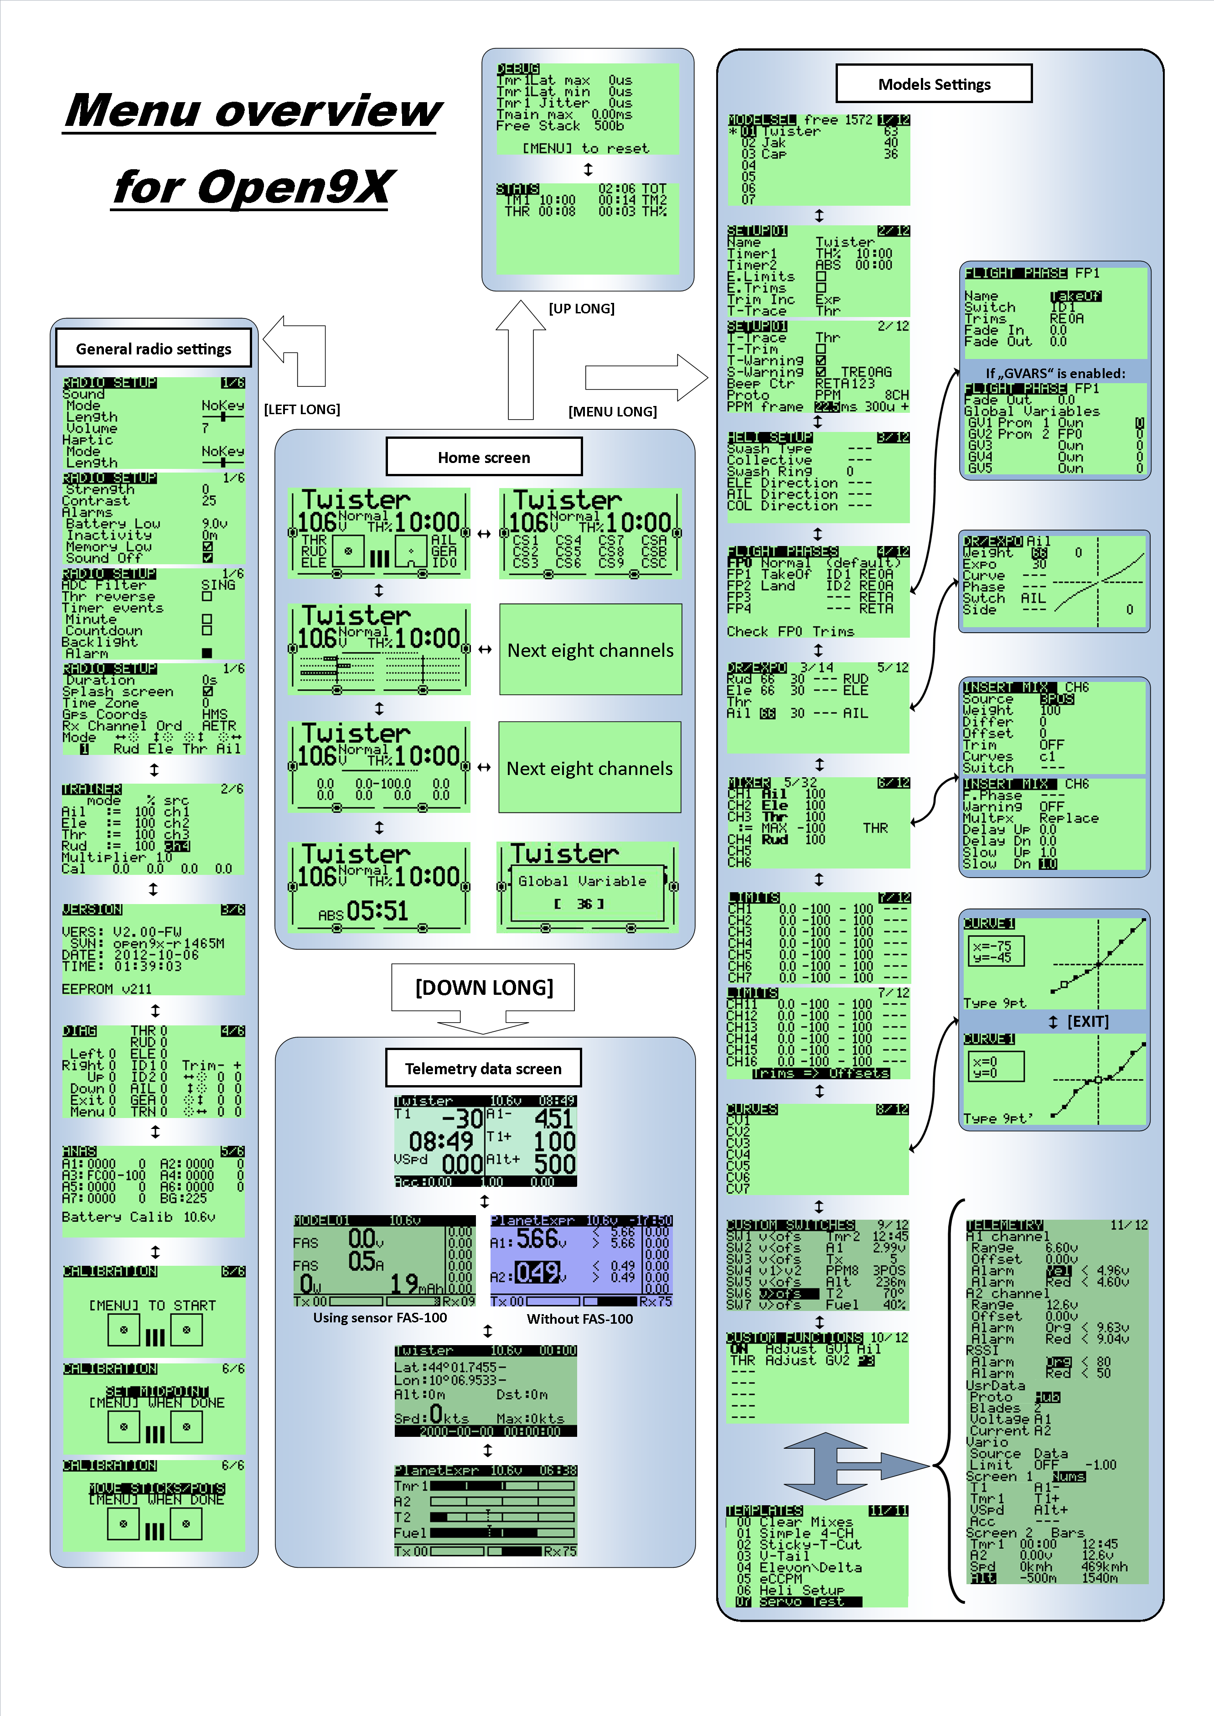
Menu Overview

Main screen

General View
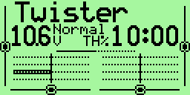
The main view is split into two parts.
The upper part consists of the following:
• The model name. Eg. Twister (a super glider, by the way)
• The name of the flight phase (when used – here “Normal”)
• The battery voltage of the transmitter (10.6V)
• The positions of the trims
• The time counter (10:00) and its mode of operation (TH%).
The lower section has four screens accessed by [UP] / [DOWN].
• Bars values ​​- They show the state of first 8 receiver outputs. For the state of second 8 outputs press [LEFT] or [RIGHT].
• Numerical values ​​- The values ​​of 8 first outputs of the receiver. For the values of second 8 outputs press [LEFT] or [RIGHT].
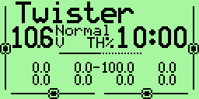

• Entry Values ​​- Position of sticks and switches. There are two screens for inputs: the physical inputs (sticks, pots, switches)
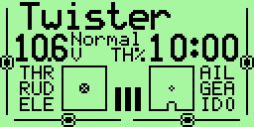

and the virtual inputs (virtual switches CS1 .. CSC) To access the second screen, press [LEFT] or [RIGHT]
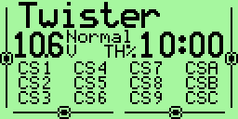
• The Timer 2 and its mode of operation: [EXIT] key resets the value of Timer 2
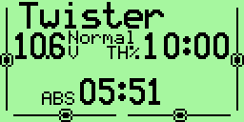
In the main view [EXIT LONG] resets the timers, counters and the telemetry data.

Screens of statistics
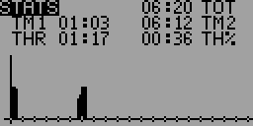
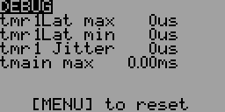
From the main screen press [UP LONG] will take you to the screens of statistics.
The first contains counters (TOT - total radio power on time, TM1 - Timer1, TM2 - Timer2, throttle stick counter to the absolute - THR and percentage – TH%).
The second shows the internal counters TX, "tmain" represents the computation time. This time increases with the complexity of the mix, it can become very large depending on the configuration of model.
You can reset this counters to 0 by pressing [MENU].

Telemetry screens
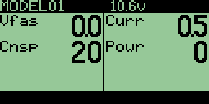
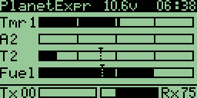
Telemetry screens will be displayed after pressing [DOWN LONG] if the option frsky is choosen. Described are in separate chapter of this manual.

General Settings
From the main screen press [LONG LEFT] will bring up the menu general settings of the TX.
These settings are independent of the selected model and therefore "universal".
The menus are:
- Radio setup
- Trainer settings
- Version info
- Diagnostics
- Analog inputs
- Calibration

Radio Setup (1/6)
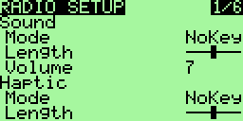
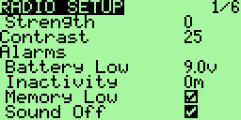
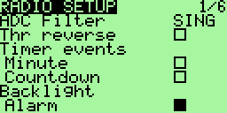
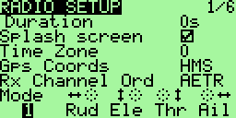
Use this screen to set the general parameters of TX:

- Sound
  - Mode: Setting when the sound are generated
- Quiet. No beeps at all, no warning, nothing, if the children are asleep and you need to adjust your radio in the living room is the mode for you. Remember when same as the TX will not warn you if the battery runs dry.(Careful with the Li-po!)
- Alarm. Only alarms (battery, radio off)
- NoKeys. Beeps but not on normal editing keys
- All. All beeps enabled!
  - Length: Length of beeps (up to xShort xLong)
  - Pitch: Adjustable Frequency of beeps (if the option audio is chosen)
  - Volume: volume of sound
- Haptic
  - Mode: Mode Setting the buzzer (if the option haptic is chosen)
- Quiet. No vibration at all
- Alarms. Only alarms (battery, radio off)
- NoKeys. Everything But the editing keys
- All. All
  - Length: Length of vibration (if the option haptic is chosen)
  - Strength: Strength of the vibrator (0 to 5) (if the option haptic is chosen)
- Contrast: LCD contrast, values ​​from 20 to 45. The higher the value the darker the screen.
- Alarms
  - Battery warning: Battery voltage warning. When the connected battery's voltage drops below this voltage the Tx will beep. Though the Tx will continue to function normally it's really advisable to land as it is known that this FW was not able to fix the “zero voltage non functionality” problem of the original.
  - Inactivity alarm: This will set up a warning that will beep if the Tx is left unattended for the specified amount of time. The default value is 10 minutes. To turn off the Inactivity timer – set the value to zero. Also, when running on USB power, the alarm is inactive. Values can be from 1 to 250 minutes. To reset the timer simply move one of the sticks.
  - Memory Low: If ON will show a warning when the available eeprom memory is less than 200 bytes when the Tx is turned on. The Tx will not output a signal until the alert is cleared.
  - Sound Off: The alarm of "last chance". This will give you a “heads up” if your beeper is silent. If on and the beeper is set to '0' (Quiet) you will receive a warning on start-up. This has been added after a programing session left a user flying on silent. I find it really useful!
- ADC Filter: Analog to Digital Conversion Filter
- SING: Converting simple, but with a faster resolution to 1024 steps.
- OSMP: Oversampling, uses more catches for 2048 steps, slightly
slower than SING.
- FILT: Filtered, available in case you have excessive noise on the conversion (servo wriggling) This setting will filter the inputs to reduce noise. It will also increase the latency time of 30 msec.
Option removed, because OSMP seems to be best for everyone. FILT didn't work properly and SING didn't give any advance over OSMP. Don't bother about this option in open9x, since you get the better resolution anyway.
- Thr(ottle) reverse: This is for all you wacky people who fly with the throttle backwards (e.i. idle is far from you and full is close to you). Though I personally don't understand how you fly like that it's a nice feature. The reverse will also reverse the throttle warning on start-up and some other throttle related functions.
- Timer Events
  - Minute: beep every minute when the meter is running ..
  - Countdown: Beep at 30, 20, 10, 3, 2 and 1 second before the end of the counter.
- Backlight
  - Alarm: Flash back-light at the beep.
  - Mode: Selecting the back-light switch on mode: OFF, Keys, Stks, Both, ON (if back-light hw mod installed).
  - Duration: Back-light duration after activation. Select from 0 to 500s.
- Splash screen: Displays the splash screen (if the option SPLASH is selected), by the way it can be skipped by pressing any button.
- Throttle warning: If ON will show a warning when throttle is not at idle when the Tx is turned on. The Tx will not output a signal until the alert is cleared. In latest versions of FW moved to model's individual selection.
- Switch warning: If ON will show a warning when the switches are not at the default position when the Tx is turned on. The Tx will not output a signal until the alert is cleared. In latest versions of FW moved to model's individual selection.
- Time zone: 1-12
- GPS coord: Select between NMEA and HMS formats of GPS coordinates
- Telemetry warning: The alarm that goes off when no data telemetry is received (if frsky option is chosen) In latest versions of FW removed.
- Rx channels ord: Allows you to choose how mixes will be applied to new models (assign channel numbers to sticks):
- RETA mean Rud = 1, Ele = 2, Thr= 3, Ail = 4.
- AETR means Ail= 1, Ele = 2, Thr = 3, Rud = 4.
- and so on ...
- Mode: Choice of stick layout between the TX MODE 1, MODE 2, MODE3 and MODE4.

Trainer (2/6)
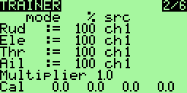
This menu allows the PPMin (trainer) inputs to be configured. It enables the RAW PPM inputs to be selected to replace the sticks for training purposes.
The student transmitter does not need to have the same model setup as the instructor. All the mixes on the instructors Tx will be applied to the student inputs. If, for example, you have expo on your sticks, this will be applied to the raw trainer inputs when they are selected.
- Mode: can take off as the value, += (student value of the handle added to master) and := (replaces the master's values ​​of the handle by the pupil's values)
- Percentage: percentage applied to the input PPM from student radio (useful when the student is a bit abrupt ...)
- Source to assign to the handle.
The multiplier is like wearing hello, it multiplies the input PPM. Useful for manufacturers of radio who can not properly encode the PPM :-P.
For calibration, highlight the "Cal" and press [MENU]. This will save the neutral point for all PPMIN channels.
Note:
In order to use trainer mode, the switch (or switches) for the transfer of proceedings between instructor and student must be assigned in the "Func Switches".

Version Info (3/6)
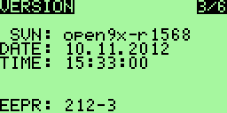
Screen displays the version of FW used.
VERS: Version Number
SVN: The SVN name of the FW
DATE: FW compilation date
TIME: Time of FW Compilation
Since that open9x is open source, I try to help all those who have problems, please
open tickets for bugs or new features on the project page:
http://code.google.com/p/open9x/issues/list
Your participation is what helps me make the best FW (and your donations of course).
Use the SVN name of this screen to report a bug, thank you.

Diagnostics (4/6)
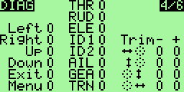
This menu will help you visualize the current state of the trims, keys and physical switches. Each Key/Switch/Trim is represented. When pressing a key or switch they are highlighted.

Analog Inputs (5/6)
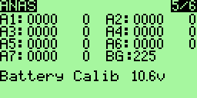
Here you can read the raw values ​​of Analog Inputs values in both hexadecimal and decimal format. Values ​​range from 0 to 0x3FF (0 .. 1023)
- A1-A4 are the sticks
- A5-A7 the potentiometers
- BG is band gap value
Also the battery voltage is measured and displayed.
On Analog Input Screen press [DOWN/UP] for highlighting the battery voltage
With [LEFT/RIGHT] you can adjust the displayed voltage value to match the value being measured with voltmeter directly connected to battery.

Calibration (6/6)
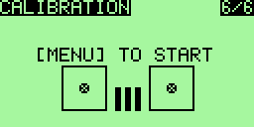
This screen allows you to calibrate the analog input A1 – A7
To calibrate this method follow:
1. Press [MENU]
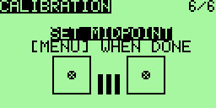
2. Put the controls (sticks and pots) in neutral
3. Press [MENU]
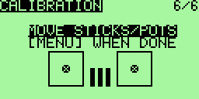
4. Move the handles and knobs from min to max. Don't forget the pots as well.
5. Press [MENU] values ​​are saved..

Models Settings
From the main screen press [RIGHT LONG] takes you to the model select/settings menus. With this menu you can adjust the following settings specifically for each model (moving between menus by [RIGHT] and [LEFT] on the top menu line).
The menus are:
- Model Selection
- Model Setup
- Settings helicopters (if the option heli is chosen)
- Phases of flight (if the option nofp is not chosen)
- DR/Expo
- Mixer (This one is most important)
- Limitations
- Curves
- Custom switches
- Functions switches
- Telemetry (if the option frsky is chosen)
- Templates (preloaded mixes - if the option templates is chosen)

Model Select (1/12)
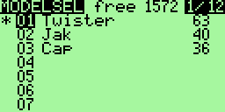
On this screen you can view, download, copy and move models among model memories. The memory management is dynamic.
The space used by each model is displayed on the right, the more complex (mixing, curves, options, limits ...) model settings will cost more space.
The star "*" on the left indicates which model is being active (loaded).
Using [UP] / [DOWN] move you among the models.
Pressing [MENU LONG] allows the loading of the selected model.

To duplicate a model:
- Choose the row to copy using the [UP] / [DOWN]
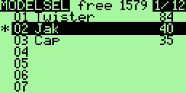
- Press the [MENU]. The line is highlighted.Then press [UP] or [DOWN] to duplicate it
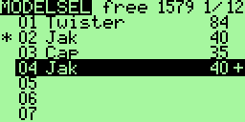
- Choose the destination location and press [MENU] to confirm.

To move a model:
- Choose the row to copy using the [UP] / [DOWN]
- Double press the [MENU]. The line is highlighted, surrounded by a
dotted bar
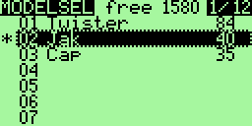
- Then press [UP] or [DOWN] to move up or down to the destination location
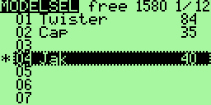
- Press [MENU] to confirm.
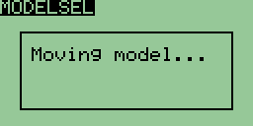
At any time during a copy operation or movement of a model it is possible to cancel
pressing the [EXIT].

To delete a model:
You can not delete the current model.
If you really want to do, you need to prior load another model.
- Choose the row to delete with the [UP] / [DOWN]
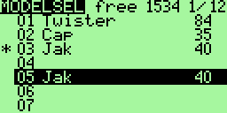
- Press the [MENU] to select
- Press the [EXIT LONG] to request the removal
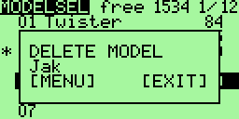
- Confirm with [MENU] or cancel with the [EXIT]

Model Setup (2/12)
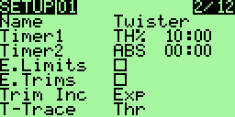
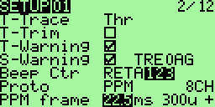
Many options are available here:
- Name: Not surprisingly this is the model name. To edit: and press down on it
[MENU].
After pressing [MENU] the first character will be highlighted.
To change the character use [UP] / [DOWN]. To move the cursor using [RIGHT] / [LEFT]. If you want to switch one letter to upper / lower case, use [RIGHT LONG] or [LEFT LONG].
Once finished, press [MENU] / [EXIT] to exit the editing
- Timer1: Setting the initial value of the counter.
Press [RIGHT] / [LEFT] to choose between seconds and minutes.
Press [MENU] and the cursor will blink. To edit using [UP] / [DOWN] / [RIGHT] /
[LEFT] and [MENU] / [EXIT] to exit.
A timer different from 0:00 will always count down, a timer equal to 0:00 is growing.
Trigger: Choose what triggers the timer (remember that by using [LEFT] you
have access to the same choice but with "!" to denote the reverse trip)
• OFF – Counter unused.
• ABS – Counter active all the time.
• THs / TH% / THT - Counter active function of engine (see below for its configuration). THs means start by moving throttle stick from minimal position and stop when return throttle stick to minimum. TH% means that the speed of the counter will be proportional to the level of gas. THt means that the counter will start at the same time as the engine, but it not stop (like Ths).
• Switches - You can specify a switch to activate the timer.
Momentary switches: A switch denoted with “m” (like TRNm) means “momentary” - pulse. That means that moving the switch once to the on position and back turns the timer on. Moving it on and off again turns the timer off. (difficult I know, take a sip from your coffee, relax a bit, take a break – it's not difficult once you try it out :) )
- Timer2: Same settings as for the Timer1
- E. Limits: Extended limits: allows deflections of 125%.
Before using this setting please verify (on servos, not only on display!) that it does not cause unwanted mixing between the channels!
- E. Trims: Extends the reach of trim from 1/8 of the race of the handle to 1/2. Note that if trim position exceeds 1/8 (value + / -125), it will flash the message on the main screen to notify to a pilot that mechanical adjustment is necessary.
- Trim Inc.: Trim increments:
- Exp – Exponential: With this the trims are fine near the center and get progressively coarser farther out.
- ExFine (Extra fine) – 1 step per click.
- Fine – 2 steps per click.
- Medium (my favorite) - 4 steps per click.
- Coarse – 8 steps per click.
- T-Trace: Choice of method for detecting the engine speed:
- Thr – throttle channel
- P1 .. P3 – Potentiometers
- CH1 .. CH16 – Output channels
- T-Trim: This is a nifty feature for combustion engine fliers. When activated a couple of things happen. First off the center detent for the throttle trim is removed. Also the throttle's trim will now only affect the “low” side. That means you can use the trim for setting idle while full throttle remains unchanged.
- T-warning: If ON will show a warning when throttle is not at idle when the Tx is turned on. The Tx will not output a signal until the alert is cleared.
- S-warning: If ON will show a warning when the switches are not at the default position when the Tx is turned on. The Tx will not output a signal until the alert is cleared.
To set “default” position of switches set all switches to the appropriate positions and press [MENU LONG].
- Beep Ctr: Beep Center. Here you set center warnings. The character string RETA123 corresponds to: Rud, Ele, Thr, Ail, P1, P2, P3. When the letter corresponding to the analog channel is highlighted the system checks for center. When the input is at center a short beep will sound enabling you to hear when the input is centered. This is useful for checking the center of the pots without looking. (Use [RIGHT] / [LEFT] to select the channel and [MENU] to enable / disable.)
- Proto: protocol encoding:
- PPM – with PPM you can choose how many channels to encode. Anything from 4 to 16 channels. PPM with 8 channels is a transmitter standard mode.
All channels are in this mode connected to RF module for transmission to model. Trainer input is not affected.
PPM with 8 channels is a transmitter standard mode.
Unused channels can be used in the mixer as the virtual channels for special function.
In the next row, you can change the parameters of the PPM frame. This can be useful for systems which might experience jitter. On the whole it might be a good idea to leave it alone.
You can set (Left to right): PPM frame length (Frame Time, usually 22ms), the minimum gap between pulses (pulse Separator, typically 300μs) and the signal polarity.
If you do not know exactly what you are doing, do not touch it!
- PPM16 - first 8 channels is transmitted to the transmitter module, the other 8 are passed to the Trainer connector. It is assumed that this connector is connected to a second transmitter module. This allows the use of 16 channels while leaving standard parameters PPM framework unchanged.
- PPMsim - all channels are sent to the Trainer connector. The transmit (RF) module is not receiving a signal. Used for connection as a simulator or for transmitter teaching mode (teacher / pupil).
- PXX: Protocol FrSky PCM.
- NumRX: Number of receiver for the Model Match.
- Sync: Failsafe definition.
- DSM2: Spektrum Protocol.
Binding: hold TRN switch when you turn the radio on. Splash Screen should be prohibited and shall be no alarm, otherwise binding not happen.
- LP2/LP4: module "short-range" obtained from micromodels radio HP6DSM (LP4DSM).
- DSMonl: only DSM2 modulation.
- DSMX: automatic selection of modulation DSMX/DSM2.
- NumRX: the receiver number for Model Match.
- RANGE: select it and press the [MENU] button to activate the range test; test completion:[MENU] or [EXIT].

Helicopters Settings (3/12)
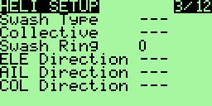
This screen is dedicated to setting a helicopter system ..
- Swash Type: defines the type of head (swash plate) of your helicopter:
- 120: "Standard" head to 120 °. The “pitch” servo is at the front / rear
- 120X: As 120 ° but rotated 90 ° so the “pitch” servo is on one side.
- 140: head to 140 ° - with “pitch” servo position forward / backward.
- 90: 90 ° Basically a simple 90° setup where you have a single servo operating the pitch and two operating the roll.
- Collective: Sets the source of the collective. The idea being that you can create a mix with all the required curves and switches and simply plug it in here to mix with the others.
- Swash Ring: Limitations of head movement (active only on channels Ail and Ele)
- ELE / AIL / COL Invert: Used to reverse the entry of these functions. Use these to make the controls move the correct way when setting up your heli.

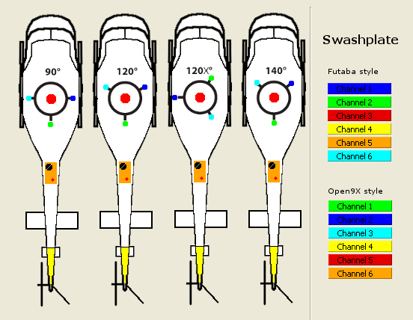

Phases of flight (4/12)
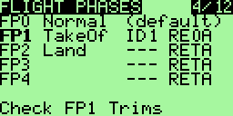
(Valid if the option nofp is not chosen.)
This screen is dedicated to the flight phases. 5 phases of flight are available. Each can be named and the corresponding label is displayed on the main screen when the phase is activated.
To change the settings of a flight phase, choose it using the [UP] [DOWN] and press [MENU].
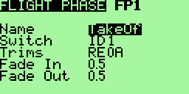
- Name: Lets you choose the label of the phase (6 characters)
Name of active Flight Phase is displayed right top from battery voltage in main screen
- Switch: Select the switch that will cause the activating this phase
- Trims: each trim (Rudder / Elevator / Throttle / Ailerons) may have their own value for each Flight Phase (options RETA) or be linked to the corresponding trim in another phase (options 01234) by selecting that phase number in place of RETA.
Example: RE0A means that trim for throttle stick is used from FP0 throttle stick (0). All other trims are autonomous.
- Fade In: allows a smooth transition when entering this phase. Transition time
from 0 to 15 seconds
- Fade Out: same as previous for output of this phase of flight
To return to the previous screen, press [EXIT]

How do i use flight modes?
Using flight mode is much for clarify and simplify the programming of complex behavior of our flying apparatuses.
Flight modes are used as a condition for activation of important settings:
- Specific trim settings for each flight mode
- Sensitivity of the control surfaces ("dual deflections") and its non-linearity (exponential)
- Activation mixes and their groups
So, for example, choose modes of flight: Normal, Take-off and Landing. FP0 will be Normal, FP1 Take-off and FP2 Landing (these names will be listing on the main screen between the transmitter battery voltage and state of the main timer - stopwatch).
As a switch that activates the mode, choose the three-way switch (ID0/1/2).
Now you can:
- Determine the trim values ​​for each flight mode (independent or common to all modes) - directly in the definition of flight modes.
- On-screen DR/Expo for each flight mode deflection sensitivity and exponential. As a condition of activation in the appropriate rows setting you can set the appropriate number of flight modes
- Create on screen Mixer mixes needed to set the flaps ev. Flaperons to the correct displacement for each mode, flaps pitching moment compensation by elevator, ejecting/retracting of landing gear, etc.. These mixes will also be activate using flight modes.
- Define time for a smooth transition between modes.

Expo/DR (5/12), Sticks
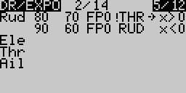
This screen is renamed to “Sticks” if the option ppmca is selected.
This screen allows you to assign an exponential, a curve or a weight to each stick (Rud/ Ele / Thr / Ail).
Furthermore, these settings can be enabled or not based on conditions on the flight phase, a switch or mode.
The curvature of the exponential characteristic is set to a value of -100 to +100. The weight
can be set from -100% to +100%.
For each set, there may be several lines of parameters. In this case, this is the first line for which all conditions are activated that is chosen and the others are ignored. There are maximum of 14 lines available for all 4 sticks.

To insert a line:
- When there is not already assigned to handle online, simply move with the keys
[UP] [DOWN] and press [MENU LONG]. Then you arrive at the setup screen
the new line.
- When there is already a dedicated line to the handle, there are two solutions: either get on the line just before with [UP] [DOWN], select it with [MENU] and press [RIGHT LONG], or get on the line right after with [UP] [DOWN], select it with [MENU] and press [LEFT LONG]

To delete a row:
Stand on the line to delete with [UP] [DOWN], select it with [MENU] and press [EXIT LONG]

To edit the values ​​in a row:
Stand on the line edit with [UP] [DOWN] and press [MENU LONG]. We arrives in the detailed menu below.

To duplicate a line:
- Stand on the line to copy, select it with [MENU]. The line is then reversed.
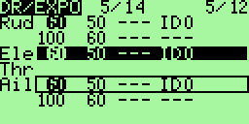
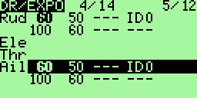
- Choose the destination using the [UP] [DOWN]
- Press [MENU] to run the duplication

To move a line:
- Stand on the line to move, select it by pressing twice the [MENU].
The line is then inverted and surrounded by a dotted line.
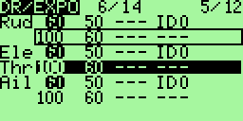
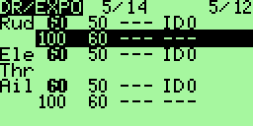
- Choose the destination using the [UP] [DOWN
- Press [MENU] to complete the move.
It can be interrupted at any time a copy operation or movement by pressing the [EXIT].

Sub-menu editing an expo:
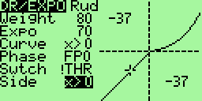
The screen consists of two parts:
- On the left are the parameters associated with the line.
- On the right is a curve as applied according to the present conditions. There are also the coordinates of the point associated with the current value of the handle.
Warning: this curve and coordinates depends not only on the current line editing but also other lines associated with the same handle!
For each line you can enter:
- Weight: the ratio for Dual Rates. As a weight can also be selected global variable (see Global variable).
- Expo: the value of expo. As a expo can also be selected global variable (see Global variable).
- Curve: A curve in addition to the expo:
- A predefined curve of x> 0, x <0, | x |, f> 0, f <0, | f |
- A custom curve c1 .. c8. Valid only if the option nocurves is not chosen.
When a custom curve is selected, you can edit it by pressing the
[MENU]
- Phase: the phase for which the line will be active. You can enter "---" (all phases), FP0 .. PF4 (phases), and !FP0 .. !PF4 (!FPx means all phases except phase x)
- Switch: the switch that will activate the line of DR/EXPO
- Side: the input range for which the line will be active (for all applications where the input is negative, or when positive)

Mixer (6/12)
This part is the most important menu.
The function of the mixer is to take the inputs, perform some function on them and route them to the output channels. Since selection is totally free you have a very flexible system which is extremely powerful and very quick to boot.

Main screen
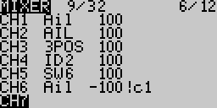
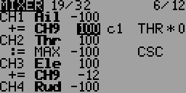
First row "19/32" = 19 used mixers from 32 available
Columns are:
- Channel number (CH1..CH16) or operator (+=/*=/:= means Add/Multiply/Replace Channel in upper rows)
- Source of mix (bold mean that this row is active)
- Weight from -125% to 125%
- Curve applied on mix row
- Switch to activate mix row
- Delay (d), Slow (s) or both (*) applied on mix row
Unlike the management of DR/EXPOS here when multiple lines are assigned to a channel, they are all applied (either the result replaces the calculation of the preceding line, or it is added, it is multiplied).
With Mixer rows we can do same Select/Copy/Move/Delete operations like in Models Setup screen
In this screen, the editing, deleting, copying and moving lines are exactly the same as for DR/EXPOS.
It is possible to edit the weights directly by accessing it with [UP]/[DOWN] and the amending with [LEFT]/[RIGHT].

Editing Mix row
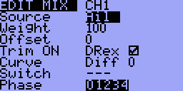
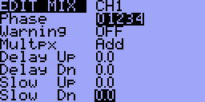
On this screen you can change the mix individually.
The selected output is mainly calculated by this formula:
CHX = Selected Curve (Source + Offset) * Weight
If there are several mixes defined for one output the output is defined by:
CHX = (Result of first mix line) + or * (Result of second mix line) ..
or replaced, dependent on chosen Multpx option.
Switches and Phases makes the mix valid or invalid. Delay and Slow is applied additionally. See details below:
The following options are available:
- Source: The source of the mix from the following choices:
- Stick or pot
- Trims – TrmA, TrmE, TrmT, TrmR – trim drivers can be used independently for setting input values. It is often used in conjunction with Thr trim control.
- MAX: Used in conjunction with a switch: the value of the mix will be either 0 or that of "Weight"
- CYC1, CYC2, CYC3: The 3 outputs of the heli swash-plate mix. Once swash mixing is turned on (Heli menu – 3/10) these become active and hold the result of the swash mix. Generally CYC1 holds the pitch output and the other two do the rolling. On the 120X mode CYC1 is the roll.
- PPM1..PPM8: PPM input channels. These are fed by the ppm input or “trainer port”. You can use these to configure a buddy system or to simply extend your radio with more functions (like head tracking for you FPV guys).
- CH1 .. CH16: Those are the outputs of the other mixes, you can use to chain
mixes to produce very complex behavior.
- User-defined logical switches CS1 .. CS9, CSA .. CSC (see chapter Custom switches).
- Weight: This value multiplies the value to the output. It can be -125% to 125%. As a weight can also be selected global variable (see chapter Global variables). Please check the formula on top to understand the order of calculation. Please note further values above 100% or below -100% do not extend range of servo, but just reaches the 100% earlier. Use Limits menu for this purpose.
- Differ (only in firmware before version r1393): The "Differential feature" is really easy to use:
- On the right aileron channel, you set +100 Weight and 60% as a differential value
- On the left aileron channel, you set -100 Weight and 60% as a differential value
It means than when your right aileron is 100% up, your left aileron will be 40% down. And vice-verse.
You have saved 2 Mixes. (There would have been another way to save mixes, using curves, but it's more complex...)
Now part of Diff Curve
- Offset: This value is added to the value from the input. It can be -125% to 125%. As a offset can also be selected global variable (see chapter Global variables). Please check the formula on top to understand the order of calculation.
- Trim: If this option is enabled (ON), the trim value for the input channel (if any) is transferred through the mix. If OFF, the value of trim will be ignored. If an entry does not have a trim (not a stick) option ON is not accessible. A specific trim (Ail, Rud, Thr, Rud) can also be selected. So you can also trim inputs that do not have their own trims. Useful especially when the trim on the handle of throttle is not used, it can be assigned to something else ...
- DRex - checkbox is used to activate / deactivate using of the dual rates and exponentials for a given input mix. If not selected, the input is from the stick directly, without correction configured in menu DR/Expo.
- Curve:
- x> 0: The value of the source will be taken into account if positive (otherwise 0)
- x <0: Same but for negative values.
- | X |: The value is passed as an absolute value.
- f> 0: If the source is a positive value is "+Weight", 0 otherwise.
- f <0: If the source is negative value will be "-Weight", 0 otherwise.
- | f |: The output will be "+Weight" or "-Weight" according to the sign of the source.
- c1 .. c8: custom curves, defined in the menu "CURVES 8/12" .
Valid only if the option nocurves is not chosen. You can also press [MENU] to directly edit the curve.
- Diff (at this point in the menu since FW version r1393):
Number on the right is the value of differentiation in %.
As a Diff can also be selected global variable (see chapter Global variables).
If set Diff 0, there is no curve used.
Differentiation function deflections is used very easily:
  - The right aileron channel set weight +100 and 60% differentiation.
  - The left aileron channel set weight -100 and also 60% differentiation.
  - This means that if the right aileron is 100% up, the left aileron is down to 40%. And vice verse.
This will save two mixes. There is another way to save mixes – using curves – but it's a little more complicated.
- Switch: Here you can select the switch that will turn the mix on. If no switch is selected then mix will be active all the time.
- Flight Phase: Here you can select the phase of flight in which will be active mixing. If no phase is selected, it will be applied to all phases.
Since firmware version r1939: You can now define (in one mix) more flight phases in which it will be active. Right next Phase is diplayed a string 01234. Each digit corresponds to the relevant flight mode. If it is highlighted (inverted display), then mix is active in the flight phase of corresponding number. It can be changed after selecting using [UP] / [DOWN] in the usual way using [LEFT] / [RIGHT] and [MENU]. Changes will stop leaving items using [UP] / [DOWN] or [EXIT].
- Warning: Here you can select an alarm when the mixing is active (only valid if a switch is selected), you can choose between 1, 2 or 3 BEEP, they will continually repeated.
- Multpx: This value defines how the mix will be added to the channel.
- Add: Its the default mode. With this value the mix is added to the previous values in the same channel.
- Multiply: Use this to multiply the previous values in the same channel.
- Replace: This value is mainly used in conjunction with a switch. When the switch is OFF the value is ignored. When the switch is ON the value discards the previous values and places it's own value in the channel.
- Delay Down / Up: Use this to delay use of this channel. Usually used with a switch. When the switch is turned “ON” or “OFF” the mixer will wait the specified number of seconds before changing the value. The delay operation is done on input side of the defined mixer line.
- Slow Down / Up: Slow the rate of change in the channel. When not zero these will determine the maximum speed with which the value can change. The specified value is the number of seconds to go between -100% to 100%.
Be aware the slow calculation is based on the input side of the mixer. That means the output speed may be different, according the function defined. E.g. a flat curve gives you a slower output change, compared to this parameter. A high slope increases output change speed. Also weight influences output speed.

Advanced information:
The mixer works internally with 16bits and 32bit integer values. 100% is internally represented by 1024 integer value and -100% equals -1024. Inside a mixer line 32bit based calculation is done, so there would not be the danger of arithmetic overflow. However between the mixer lines 16bits are used which can cause arithmetic overflows.
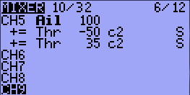
What ever is caculated inside the mixer lines there is a arithmetic reserve of a factor 32 above 100%. That means there may be a calculation in the first line which results in 300% and the seconds lines substracts it back to -100% to 100%. This is still OK. However if it comes above 3200% (32 times 100%) there is a danger of overflows or arithmetic faults. Carefully test your mixer lines before actually using it, if you go much beyond +-100%.

Limits will not effect the mixer calculation because this is handled separately.

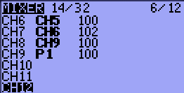

Also the timing is interesting. The mixer does actually loop over the mixer lines several times if needed. This is the case, when on mixline causes a output for a other mix line. To give an example. If mixline 1 generates a output for mixline 2 (CH6 is used for CH7) it is calculated in one round and would not increase mix calculation time. If it is defined vice versa the mixer still does it right, but needs two runs to catch the output from mixline CH9 and use it for mixline CH8.
Therefore it is always better to do dependencies from top to down to prevent unneeded mixer loops. In this case exchange the lines for CH9 and CH8. Mixer calculation time can be monitored in Debug Screen. You can enable Debug Screen with a long [UP] and then again [UP].

Limits (7/12), Outputs
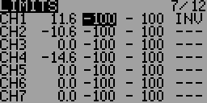
If the choice ppmca is active then this page is (in English firmware) renamed to “Outputs” and has a slightly different layout. The layout is altered also if the symlimits option is selected.
This is probably the second most important menu. The limits operate on the output channels (as you can see from the picture in the introduction). In the LIMITS menu you can set the center point (sub-trim), limits (both left and right) and reverse the channel's output (INV – invert).
Each channel is represented by a channel of your receiver. The limits will be used on the channel indicated.
Columns:
- Offset : (or SubTrim): This sets the channel's center point.
The values of SubTrim can be -100 to 100 with increments of 0.1. This is done so to have excellent resolution when setting the center of each surface.
HINT: You can use your stick to set the center point as well. While the SubTrim is highlighted, hold the stick so that surface is centered. Press [MENU LONG] and the position will be recorded!
- Minimum channel Limit: and
- Maximum channel Limit : These two columns set channel endpoints.
If the option "E.Limits" is ON then they can be in the range from +25% to -125% for the minimum and -25% to 125% for the maximum, otherwise the range is from +25% to -100% and -25% to +100%.
Limits act as the "output gain" (indicates how many % servo throw is 100% of the output of the mixer) and at the same time as absolute limits. Servos can never get the order to sweep through the value set here.
Notice that there's an indication column that hints which side is active at the moment.
The value can be changed in the usual way – after after selecting the values ​​and press [MENU] using [UP], [DOWN], [LEFT] and [RIGHT].
- If the option ppmca is not chosen, then there is an indication column (with values: ->, -,<-), located between these two columns (described above). This column indicates whether the current value in the channel is zero or direction toward applicable limit. This indication is omitted if the option ppmca is chosen.
- INV: reversion. This function allows you to reverse the output value for the channel. Use to match the servo signal direction to the method of servo installation in the model. The values ​​are '<-' (reverse) and "->" (direct output) if the option ppmca is chosen. If the option ppmca is not chosen the values are "INV" and "---". Changes can be made after highlighting (using [LEFT] and [RIGHT]), by pressing [MENU].
- PPM center value (in microseconds). This is displayed if the option ppmca is chosen on build time.
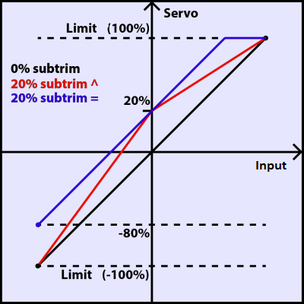
- Kind of limits: Choice between the classic ('^') and symmetric ("=") limits. This column appear in FW since r1438 if the option symlimits is chosen.
Classical Limits: Limits are set equal to the value of -100% and 100%, where the change in value is linear from the center (defined by sub-trim) to limit (red chart).
Symmetric limits: channel values are symmetrical from the center defined by sub-trim on both sides. The adjusted value can not correspond to -100% and 100%, will only limit the maximum deflection (blue chart).

Trims2Offsets
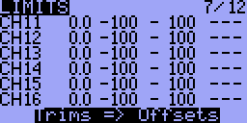
You can find Trims2Offsets function on last line of limits screen. We can use it to transfer all trims values to offsets after flight. Pressing [LONG MENU] on line Trims => Offsets results in storing each Trim value to corresponding Channels Offsets. Trims are cleared.

Curves (8/12)
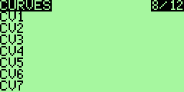
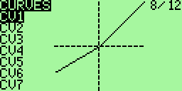
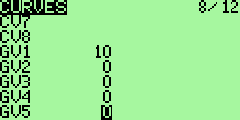
Curves are essentially rules describing how an output signal is dependent on the input.
Perhaps the best known applications of curves is setting for the mix of a throttle and a collective of helicopter. But applications are to be found much more. At random, include one of the methods of implementation differential ailerons, or perhaps setting deflection of flaps controlled by flight modes three-position switch.
In newer versions open9x an items for monitoring and changing the values ​​of global variables are added to this menu (see Global Variables chapter).

Types of curves
The curves are very useful to define the movement of the servo when you move your handle. In open9x there are 8 curves available. Any of the curves can be 3-point, 5-point, 9-point and 17-point.
A 3pt curve is a curve you can edit at position -100%, 0%, 100%.
A 5pt curve is a curve you can edit at position -100%, -50%, 0%, 50%, 100%.
A 9pt curve is a curve you can edit at position -100%, -75%, -50%, -25%, 0%, 25%, 50%, 75%, 100%.
A 17pt curve is a curve you can edit at position -100%, -88%, -75%, -63%, -50%, -38%, -25%, -13%, 0%, 12%, 25%, 37%, 50%, 62%, 75%, 87%, 100%.
There is a type of curve with the possibility that the value of the x coordinate of each point can be changed. This type of curve has a name with an apostrophe attached at the end.
All curves share a common memory area. This means that it may not be possible to use all eight such curves with 17 points each.

Edit curves
When you enter this menu you should see a long list of curves. Go down to the curve you wish to modify and then press [MENU] or [RIGHT]. This will take you to the curve edit screen. Depending on whether you choose a curve has 3, 5, 9 or 17 points you will see 3-17 points editable.

Y-coordinate setting
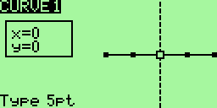
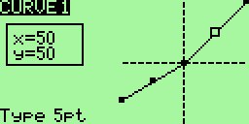
You move from point to point with [LEFT] / [RIGHT]. Change the value with [UP] / [DOWN]. When editing is finished, press double [EXIT] to return to the previous menu.

X-coordinate setting
There is a type of curve with the possibility that the value of the x coordinate of each point can be changed. This type of curve has a name with an apostrophe attached at the end.
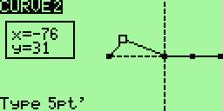
If you edit a curve, allowing changes to the x-coordinate of each point, you can also move each point in the x-coordinate.
Select a point and press [MENU]. Selected point blinks. Then you can move the point in the direction of the x (and y) coordinate by pressing the [LEFT] / [RIGHT] (and [UP] / [DOWN]).
When editing is finished, press [MENU] or [EXIT]. You can then go to the next point.

Selecting the type of curve
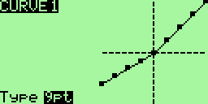
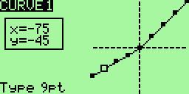
The first press of [EXIT] moves the cursor to the type of curve selection field. Then you can press the [LEFT] / [RIGHT] to change the type of the curve. Press [MENU] for return to curve editing, [EXIT] to close curve editing and return to curves selection (main) screen.

Custom switches (9/12)
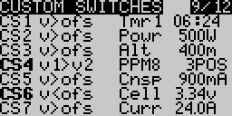
Custom switches are not really switches at all but rather a set of logical conditions that can be used as switches.
You might have noticed that beyond the physical switches there are 12 switches called CS1..CS9 and CSA..CSC. These correspond to the list you see in this screen. Once the condition defined for the switch is met it's value will be “ON”
- First we define the condition. This can be v>offset, v<offset, |v|>offset, |v|<offset, d >= ofs, | d | >= ofs, or it can be a logical condition: AND, OR, XOR, or it can be a comparison between 2 sources.
Here, "v" mean value and "d" indicates the difference (change).
Use "| v |" and "| d |" to specify the requirement to evaluate arithmetic absolute value (| 10 | and | -10 | is the same and equal to 10).
- If you have chosen a conventional operation must specify a source and a value:
  - The source may be a stick, a pot, a PPM input, an output channel (CHxx), a Timer (TMR1, TMR2) or an input from telemetry.
  - An offset is a value that will serve as a point of comparison.
Examples:
- CS1 v> ofs POT1 10 - will be active if the POT1 value is greater than 10
- CS1 | v |> ofs POT1 10 - will be active if the value of POT1 is greater than 10 or less than -10
- CS1 d> ofs POT1 10 - will be active if the value of POT1 increases by 10
- CS1 | d |> ofs POT1 10 - will be active if the value of POT1 changes by 10
- If you chose a logical operation the result will be that the condition applied to two selected switches.
For example: OR ID1 ID2 will be “ON” if either ID1 or ID2 is on.
- If you selected a comparison ("==", ">", "<" etc. ...) you must select two sources to be compared.
For example: Switch on only if CH1 is less than Rud → v1<v2 CH1 Rud
Example:
Imagine that you have a glow plug igniter to activate when the throttle is <10%:
- Highlight CS1
- Select THR as the source.
- Choose an offset of -80 (remember 10% from -100 to 100 is 20% above the slowing -80).
- Select the condition v <ofs.
Now you need a mixer to use switch CS1, go to the menu mix, select CH8 for your glow plug. Take this path "MAX" in source and CS1 as "Switch". And now whenever the throttle goes below 10%, CH8 will go to 100%. Cool, huh?
Overview of allowable input values​​:
v | Description | Value Range
Rud | Value of rudder channel | -125 to +125
Ele | Value of elevator channel | -125 to +125
Thr | Value of throttle channel | -125 to +125
Ail | Value of Aileron channel | -125 to +125
P1 | Value of Pot 1 (top left) | -125 to +125
P2 | Value of Pot 2 (top right) | -125 to +125
P3 | Value of Pot 3 (front left) | -125 to +125
Rea | Rotary Encoder A (if installed)  Dimmed if not available | -100 to +100
Reb | Rotary Encoder B (if installed) | -100 to +100
TrmR | Rudder trim switch value | -100 to +100
TrmE | Elevator trim switch value | -100 to +100
TrmT | Throttle trim switch value | -100 to +100
TrmA | Aileron trim switch value | -100 to +100
MAX | Constant maximum value determined by weight. The value of the variable is (depending on the position of switch) either 0 (zero), or the value of the "Weight". | -125 to +125
3POS | 3 position switch. End points determined by weight setting | -weight or 0 or +weight
CYC1 | Swashplate mix 1
CYC2 | Swashplate mix 2
CYC3 | Swashplate mix 3
PPM 1 - 8 | The values ​​of the channels PPM (connector Trainer) No. 1-8
Ch 1 - 32 | Value of Channel 1 - 32 | -125 to +125
Timer 1 | Timer 1 | Measured in seconds
Timer 2 | Timer 2 | Measured in seconds
TX | Transmitter RSSI | between 0 and 100
RX | Receiver RSSI | between 0 and 100
A1 | Analog port1 on Frsky receivers
A2 | Analog port2 on Frsky receivers
Alt | Altitude from FrSky altitude sensor | Metric or imperial based on compilation used
Rpm | RPM optical Frsky sensor | Set number of prop bladed on telemetry setup page
Fuel | FrSky Fuel Sensor | Percentage
T1 | Temperature 1 from Frsky temp sensor 1
T2 | Temperature 2 from Frsky temperature 2
Speed | Speed From Frsky GPS | Metric or imperial based on compilation used
Dist | Distance from origin From Frsky GPS | Metric or imperial based on compilation used
GPS Alt | Altitude From Frsky GPS | Metric or imperial based on compilation used
Cell | Lowest Cell on FLVS | volts
Cels | Sum of all cells on FLVS | volts
Vfas | Voltage detected by FAS100 or FAS40 | volts
Curr | Amperage FAS or analog configured on telemetry page | mAmps
CNsp | Total mAh used | mAh
Powr | Power,  voltage source used is configured on telemetry page, current as above | Watts

Func Switches (10/12)
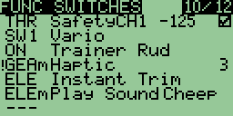
This screen allows you to associate one or more functions for one switch.
For example you may need a security switch on the throttle channel to be able to adjust your electric model without fear of starting the propeller due to an error of programming (or an unfortunate attachment of the throttle stick).
To do this, you will associate a switch (eg. THR) with the "Security Ch" on the throttle channel with a value of throttle power off. (This function adds just one extra level of security to reduce our passion risks).
You may set actions for all type of switches:
- Physical switches (THR, AIL, ID0, ....),
- Logical switches (CS1-CSC, always ON),
- Momentary switches (THRm, CS1m, ONm, ...) they are switched only once and then their condition return back. Usually for playing sound, for landing gear, instant trim...
- and all above Negative switches (!THR, !CS1, !RUDm, ...)
Functions:
- Safety channels CH1 .. CH16 with adjustable output value from -100 to 100 and ON/OFF check box to increase safety while setting up values.
- Trainer
- Trainer for a single channel (Rud / Ele / Thr / Ail)
- Instant Trim to trim your model instantly from the stick positions.
Note: Trims are not transferred for Thr stick.
New trim values are active for each Flight Phase where same trims are used.
If +-25% trim is not enough, activate extended trims (+-100%) in model setup screen.
- Play Sound: play a sound
- Vario to enable vario audio warnings (see section Configuring a Vario).
- Reset. As a parameter you can choose what you want to reset: Timer1, Timer2, Telem. (telemetry) or All.
- Haptic run vibration (needs Haptic Mod and haptic firmware option)
- Beep
- Backlight controls the back-light. Requires installed back-light mod with with an add for control back-light by firmware.
- Global variables: Adjust GV1 - Adjust GV5. Used to determine the source of values ​​for global variables. See chapter Global Variables.

Telemetry (11/12)
(valid only if option frsky is activated)
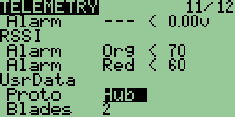
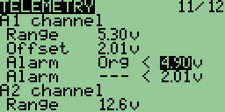
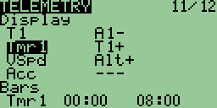
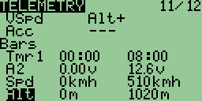
In this menu are all the settings for displaying telemetry FrSky, and the configuration associated alarms.

Analog inputs A1 and A2:
For each entry, you can set the following:
- Range: the received range of values, for a voltage for example, from 0 to 204.0 v!
- Offset: a shift, allowing a finer calibration
- Two alarms corresponding to alarms module FrSky:
- Alarm level (---, yellow, orange, red)
- Sense of alarm from the threshold (< or >)
- Threshold value
When a value is modified, it is immediately sent to the module FrSky.

Reception levels (RSSI) Tx and Rx:
Same principle, it is possible to set two alarms to the reception level:
- The alarm level (---, yellow, orange, red)
- The threshold value
When a value is modified, it is immediately sent to the module FrSky.

The format of the serial protocol received (UsrData):
- Proto: Protocol used. This is the serial protocol used by the telemetry receiver. The
options are: None (not used), the Hub FrSky or module Winged Shadow How High (he gives only the altitude, but it is more accurate) - WSHHigh
- Blades: The number of propeller blades for displaying the tachometer

The configuration of the gauge displayed on the screen Telemetry:

It can display up to 4 gauges on the screen telemetry. Here are the parameters:
- Source: what will be displayed
- Min: the minimum value displayed
- Max: the max value displayed
Milestones displayed on the screen automatically from telemetry information from alarms FrSky, or virtual switches. So if you set a virtual switch when the altitude is 400 m, you will see a mark at 400m.

Templates (12/12)
(valid only if option templates is activated)
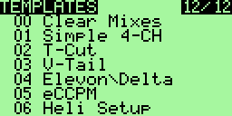
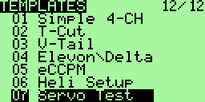
The templates are here to help with settings for a model. Entering this menu you will see the list of available templates. To choose a template, scroll down to it and press [MEU LONG]. This will add the template to the existing mix of the current model. Firmware in this process respects sticks to output channels assignment from item “RX Channel Ord” on “Radio Setup” screen.
At the top of the list you will see the option Clear Mixes. Pressing [MENU LONG] on this value eliminates all mixing of the current model.
The templates available:
- Simple 4-CH: Classic 4 channel aircraft.
- T-Cut: This adds a throttle cut mix on your throttle channel.
- V-Tail: Tail in V.
- Elevon / Delta: Lift up or mixing for delta wing.
- eCCPM: A generic mixing for electric collective pitch.
- Heli Setup: Use upstream of eCCPM: resets the mixer and curves for eCCPM use.
- Servo Test: Set up a test signal on the servo CH15. To test a servo track with a mix CH15 and your servos will move slowly from -100 to 100.

Telemetry screens
(valid only if the option frsky is chosen)
These screens are accessed by pressing [DOWN LONG] from the main menu. In depending on what you have configured, views may differ. You move from one screen to the other using the [UP] [DOWN]. The [MENU] button resets the telemetry data. Finally [EXIT] returns to the main menu.

Gauges

Inputs A1 and A2 with Min and Max, as well as LiPo

Data from the altimeter, tachometer ...

GPS data
Here shows the latitude, longitude and altitude of the model, and the distance of the model driver. By resetting the telemetry data, the first GPS position received becomes the known position of the driver for future calculations.

Telemetry alarms
There are three types of alarms:
- Alerts from Frsky DHT/DIY module beeper (Yellow/Orange/Red - 1/2/3 beeps)
- Warnings from T9x beeper/speaker/vibra motor (depends on Audio_Mods you have)
- Notifications dependent on vario sensor

Alerts
are only from A1/A2/RSSI inputs and they are generated by Frsky DHT/DIY module beeper. They are based on received A1/A2/RSSI values from Frsky RX. When NO telemetry DATA from RX, no alarms. Or better to say when DATA was there before, last known value is used to start or not start the alarm.
In open9x telemetry screen you can set up these type of alarms like Yellow, Orange, Red alarm thresholds. And they are stored to Frsky DHT/DIY module for selected model. These thresholds are also shown like small arrows in telemetry bars screen for A1/A2/RSSI only bars. Values below threshold are DOTTED bars.
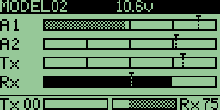

Warnings
are feedback's from Function Switches>Play Sound or Haptic ... menu and you can set thresholds in Custom Switches menu. This type of alarm can be set up for all possible events from Custom Switches (Frsky HUB sensors, Timers, PPM, Stick, Channel values..... and also for A1/A2 and RSSI).
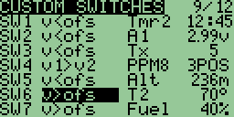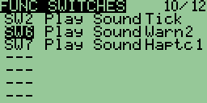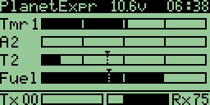
Bars for Temperature 1 and 2 are DOTTED when values are herein-before threshold.
Remember 2nd alarms are not only telemetry alarms, they are "open9x" alarms for any possible input and it's threshold. And because of this, when NO telemetry DATA from RX are received, the values for thresholds in Custom Switches are still active and hence open9x will Play Sound selected in Function Switches.

Configuring a Vario
Open9x now supports an advanced Vario to help you sniff out thermals. To use a vario you have a choice of products.
- The thermal scout product released by Winged Shadow http://www.wingedshadow.com/
- The standard FrSky hub and Vario product http://www.frsky-rc.com/
- The new Halcyon project started by members of this forum! http://code.google.com/p/halcyon/
Configuring your vario is achieved as follows:
Visit the telemetry configuration page and scroll down to the section called 'vario'. You will need to select a source for your vario signal. You have a choice of 'BaroV1|BaroV2|A1|A2'.
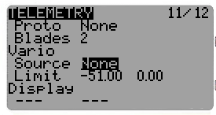
If you are using the FRSky choose BaroV1, Halcyon systems choose the option BaroV2. If you are using the Thermal Scout System; choose the A1/2 channel you are plugged in to.
Note. If using A1/A2 you will need to enable the alarm for this A1/A2 channel further above in the telemetry screen.
You will note that the values have been set to 3.2m/s and offset -1.6m/s. This is to match up to the WS system that sends 1.6v as a signal for no lift, and up to 3.2v to indicate lift strength.
There is no need to configure alarms for the A1/A2 Channel.
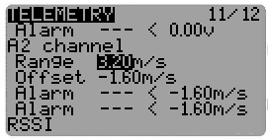
When configuring the vario you will note the two options 'Limit'. These options WILL require a little bit of tweaking to get your vario working to your personal taste!
The two values on limits are:
- Minimal negative vertical speed where sounds starts to play (continuous beeps), possible values: OFF - no sound at all for negative vertical speeds, -10.0..0.0 range
- Minimal positive vertical speed where sound starts to play, possible values: -1.0..2.0, This is a little confusing -1.0, so need example can be shown as follows:
If you set -0.5 there in second field positive indication starts on -0.5 vertical speed, it means: if you have normal (for glider) always -1m/s and found weak thermal flow -0.5 mean you have profit +0.5(-1m/s your normal + 0.5m/s air flow = -0.5m/s which is better than -1m/s)! because you have found weak thermal flow or side of good flow.
What settings? When using a winged shadow system, good staring values for the Range & Offset are 10.16m/s and -5.08 respectively!
Note: With Audio Mod and audio firmware option you will have different cadence and sound for positive vertical speed strength.
Finally.. you need to enable the vario to actually play some sound!
This is done in the 'function switches' configuration. Simply choose a switch.. and select the function 'Vario'.
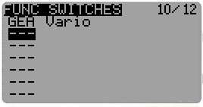
All going well.. you will not have a vario to help you sniff out the lift!

Current sensor
There are two types of current sensors
- FrSky FAS-100 current sensor connected do data port of receiver or through Hub
- external sensors connected to A1 or A1 receiver inputs
Using current sensor you are able to measure the instantaneous current, consumed capacity of battery and with voltage measurement also the power.
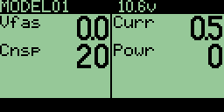
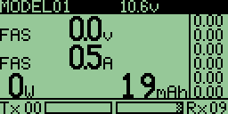
For both type of sensors you must set up open9x telemetry screen UsrData section.
- Proto to None or Hub depending if you are using A1, A2 inputs for voltage and current sensor or FrSky Hub.
- Voltage to A1, A2, FAS or Cel depending what is your voltage sensor. A1/A2 are external voltage sensors connected directly to corresponding inputs. FAS is voltage measurement from FAS-100 sensor and Cell is voltage measurement from FLVS-01 sensor.
- Current to A1, A2, FAS depending what is your current sensor. A1/A2 are external current sensors connected directly to corresponding inputs. FAS is current measurement from FAS-100 sensor.

FAS-100
With this sensor it is enough to set the UserData section in telemetry setup screen.
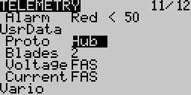

External sensors
If using external voltage and current sensors, in addition of setting up UserData section we need to setup A1 and A2 channel Range , Unit(v or A) and if needed Offset.
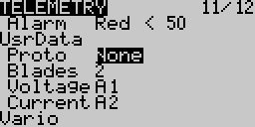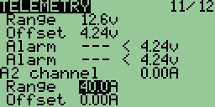

Global variables
(This functionality is only available if the option gvars is active.)
Global variables are used to expand the ability to enter input values ​​in mixers, dual rates and expo's.
These variables allow for example, modify the settings of selected functions in flight, using
controls: potentiometers, stick and trim controls.
Each of the variables may have a special value for each flight mode (flight phase) (This is still not true for stock T9X board.)
This allows significantly reduce the number of mixes and differentiation.

Assigning a value
Checking and direct value change is done in the open9x on different motherboards differently. It has to do with relation to flight modes, which works on all boards except T9X stock board.

Standard motherboard:
For standard base plate (with standard M64 processor) is available just one common set of GV for all flight modes. You can work with them in the menu Curves.
Global variables are shown at the bottom of the menu under the designation GVx (where x = 1-5).
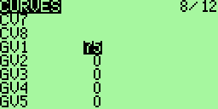
Value can be changed by highlighting directly using [LEFT] and [RIGHT] or pressing [MENU] using [LEFT], [RIGHT], [DOWN] and [UP].
Entering then ends with [MENU] or [EXIT].

Gruvin, Sky9X and standard board with processor M128:
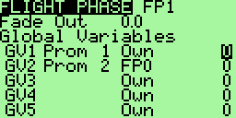
For these variants of the motherboard we have a separate set of GV for each flight mode, and variables can be named. You can work with them in the menu Flight Phases.
Global variables, assignment flight regimes, and the names of global variables are set in the Global Variables section using normal procedures. Value “Own” means that the global variable is for the flight mode specific value, the value FPx (x = 0-4) indicates that the value is shared with the selected flight mode x.
Value can be changed by highlighting and pressing [MENU] using [LEFT], [RIGHT], [DOWN] and [UP]. Entering then ends with [MENU] or [EXIT].

Setting the source of global variables:
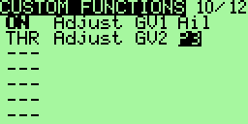
Method of obtaining the values ​​of global variables can be set on screen Custom Functions (Function), select Adjust GVx function (where x is 1-5).
As a source of values ​​you can use all analog values ​​(Rud, Ele, Thr, Ail, P1, P2, P3, TmrR, TmrE, TmrT, TmrA, MAX, 3POS, CYC1, CYC2, CYC3, PPM1-PPM8, CH1-CH16).

Use
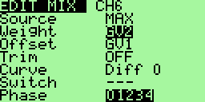
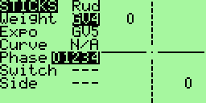
Global variables can be used in many places instead of numeric values, ev. instead of other inputs. On location where it is to use a global variable, use [MENU LONG]. The content of the highlighted box will change to GV1. Use the [LEFT] and [RIGHT] to select other global variables GV2-GV5.
If you need to cancel the use of global variables, use [MENU LONG] again. The set values will stay maintained.
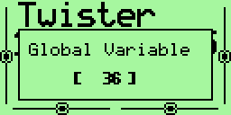
When you change a global variable, the information window with the new value is displayed for a short time.

Examples

A throttle-cutting program
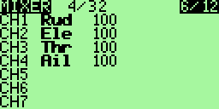
Although you can do with a template via the instructions here mixes. Start with
a conventional 4-channel mixer. Get off on the throttle channel like this
Press [MENU] to select the line and [RIGHT LONG] to add a line after the current and enter the menu "Edit Mix".
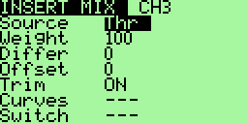
Change the source by "MAX" and weight "weight" by -100.
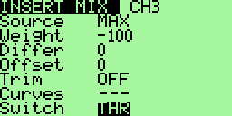
Remember to select a switch.
Continue down until you reach "Multpx". Change the default "Replace"
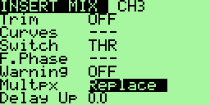
Now press [EXIT]
You should get the following screen:
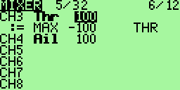
This indicates that you have two mixes on the way CH3.
The first uses the value of the throttle stick. The second depends on the state of switch THR. When THR is ​​OFF then mix is ignored and CH3 has the value of the handle. If THR is ON, the value of CH3 is -100%.

Instructions for building and programming
You'll want to modify the code to your own needs, it is very easy if you know the C language.
First to program the microcontroller following the instructions: Flashing the 9x by Jon Lowe.

Building from source
Of course you need a crosscompiler to be able to compile the sources. You can use WinAVR for this reason. Just do a search on the internet for WinAVR, it is free. To get better compilation results, you should use gcc 4.7.2 or newer if available. Do a search for “avr-gcc snapshots” to have a starting point on windows plattform. Better results are reached on Linux based plattforms.
Use SVN to get sources: svn checkout http://open9x.googlecode.com/svn/trunk/ open9x
Put yourself in the src
To compile the standard version: make
For version FrSky enter: make EXT=FRSKY

Building Options:
PCB | The main board of the transmitter can be replaced by more powerful board versions that provide more features and computing power. Open9x is available for the stock PCB, the gruvin9x v4 PCB or the ersky9x PCB
Language | All open9x versions are available in any of the following languages: Czech, English, French, German, Italian, Swedish
frsky | Support for the Fr-Sky telemetry enabled radio system with telemetry data display on the '9x transmitter screen. That means that there is no need for an external telemetry screen! All telemetry systems require hardware modifications of the radio.
jeti | Also a telemetry system
ardupilot | Also a telemetry system
nmea | Also a telemetry system
heli | Includes a configuration page for helicopters. If you do not fly helicopters you do not need this page.
templates | Includes a configuration page with templates for a number of common types of models. A more advanced user will typically remove this page to preserve space.
nosplash | Used to remove splash screen and preserve space for other options.
nofp | Removes Flight Phases configuration page to simplify setup and preserve space.
audio | The standard beep of the radio is horrible. It is possible to make a HW mod for this and this option makes it possible to control that modification
haptic | Support for haptic HW modification of the radio (that is addition of vibrations during the beeps)
PXX | Support for PXX radio protocol
DSM2 | Support for DSM2 radio protocol
ppmca | Adds possibility for PPM center adjustment
potscroll | Uses potentiometers to scroll in menus.
autoswitch | During model setup it is possible to select and set switches by moving them.
nographics | Disabling graphic of sliders and check boxes
pgbar | Shows a small progress bar when data are stored in the transmitter memory
imperial | Uses imperial units rather than the standard metric ones.
gvars | Makes global variables available

Examples:

make audio=YES PXX=YES pgbar=YES gvars=YES
make NAVIGATION=POTS AUTOSWITCH=YES AUDIO=YES PXX=YES DSM2=PPM
EEPROM_PROGRESS_BAR=YES GVARS=YES

If successful there is a file called open9x.hex generated in the src folder.

(See this page: http://code.google.com/p/open9x/wiki/CompilationOptions to full list
of options)

Flashing (reprogramming of the radio)
(In Linux you have to be admin for that USB port on)
To write the FW: make wflash AVRDUDE_PROGRAMMER=usbasp
Write to EEPROM: make weeprom AVRDUDE_PROGRAMMER=usbasp
To read the FW: make rflash AVRDUDE_PROGRAMMER=usbasp TARGET=backupflash
For the EEPROM read: make reeprom AVRDUDE_PROGRAMMER=usbasp TARGET=backupeeprom
Remember to replace "usbasp" by the name of "your programmer.
For a list of supported type programmer: avrdude-c?

Make Targets
- make all (default): Compile sources
- make clean: Deletes the compiled files and folders.
- make wflash: Write flash (program) memory.
- make rflash: Reads the FW.
- make weeprom: Program the eeprom.
- make reeprom: Reads the EEPROM.
- make coff: Convert ELF to AVR COFF.
- make extcoff: Convert ELF to AVR Extended COFF.
- make debug: Starts the debugger.
- make simu: Starts the simulator (which is used for including screenshots)

MORE

From author of the software:
I hope you enjoy the open9x FW!
This is an Open Source project, which means I do not ask for money in return, and you are free to view, download, edit and re-distribute the code under GNU v2 license.
If you have any questions, improvements, or to submit compliments, I would be happy to to read either on the official project page: http://code.google.com/p/open9x/
Either on the forums 9xgroups: http://9xforums.com/forum/viewforum.php?f=45
Specifically for bugs / enhancements: http://code.google.com/p/open9x/issues/list
open9x and companion9x are free to use under the GNU License v2.0. I spent (and continue) much time to make this software as good as possible.
Open9x is free to use under the GNU GPL v2.0 License. Feel free to use, copy and modify it as you wish! If you feel that this software has been beneficial you can show your support by donating to MSF. Please tell-us that you did it and you'll be added to the "donators" list.

http://www.msf.org.uk/support_our_work.aspx
Advertise for this cheap radio to your friends, I bet he will look at you with big eyes exclaiming that you'd better go buy a "real" radio. It does not matter, you will have more money for "real" aircraft!
Yours Bertrand

From translator into English:
When I wrote for myself a quick English translation of the French manual, originally I did not expect that I will continue to maintain it and distribute. Mainly because I can not speak or read French, and relatively less familiar with English.
I made ​​a translation using Google Translator (into English because the translation from French to Czech basically did not work).
Then I was asked to publish my translation as a temporary official English manual. And then I tried to improve the manual and keep it up to date.
Now (beginning of the November 2012) is promised official English translation of the new official French manual, produced by a group of French authors.
This ends the brief period when my rugged translation was only a crutch for people who can not read French.
This is therefore probably the last update of my translation.
I hope that at least some of the approximately 2,500 people who downloaded the translation, my work has helped.
And I hope I have not offended feelings of English native speakers. (Well, you caused it yourself, you could competently translate the manual instead of me. :))
Yours Zdeněk

